Go Formative – Quick Guide
Checklist before using pickers with students:  - Create an account at www.goformative.com  - Create classes  - Ask students to self-enroll  - Create an assignment | 
Tips:
- Use Google Chrome
- Take advantage of the speed of the touch screen laptops.
- Have students register for the site after they finish a test/quiz. Use the class code.
- You do not have to enter all of your questions on the web site. You can enter “#1” on the site and then project the question on your smart board/interactive projector.
Where should you start?
- Create an account at Go Formative.com  - Sign-up  - Pick teacher  - Fill out the form and click ‘create free account.’  - Create New Class  - Five Ways to Enroll your students  - I recommend students joining your class themselves  - Display your class code  - Direct students to www.goformative.com/#signup  - Students sign-up and enter your Class Code  - Create Assignments (Dashboard)  - Go to the dashboard  - Name the assignment and click ‘add question.’  - Determine the type of question (multiple choice, open ended, true/false). | 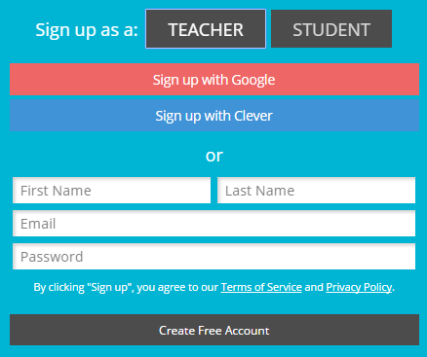
How can you use Go Formative in your class?
- Formative Assessment
  - “Formal and Informal Checks for Understanding”
  - Review Homework
  - Exit Slip
- Real Time Intervention
  - Determine where to go next in your lesson.
  - Visually see who needs help.

